**PROGRAM SOURCE**:

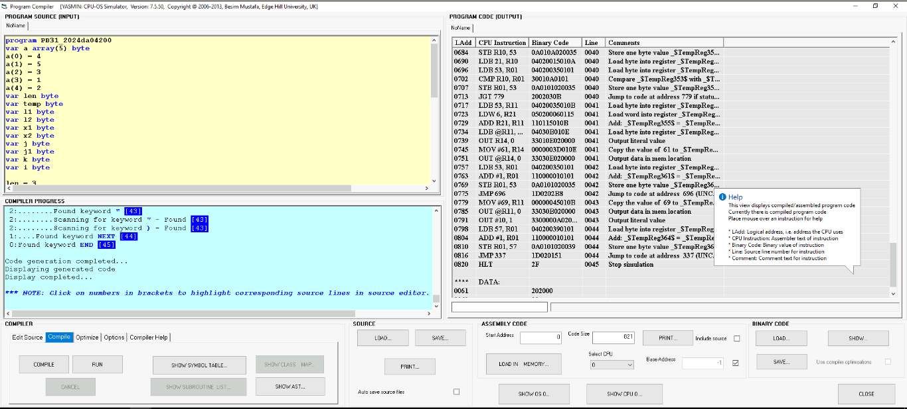ID - 2024da04200

**REPLACEMENT ALGORITHM:** RANDOM

1. BLOCK SIZE = 4, CACHE SIZE = 4

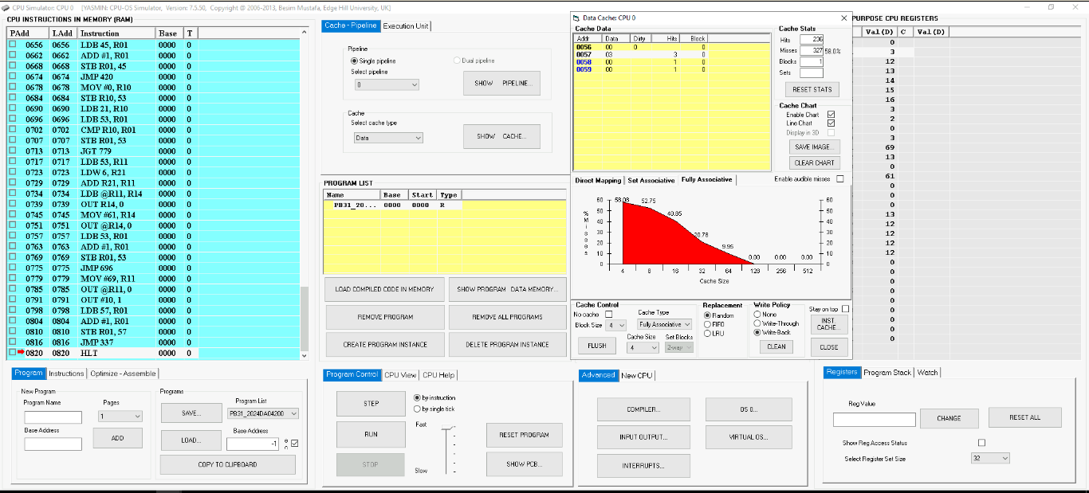

1. BLOCK SIZE = 4, CACHE SIZE = 8

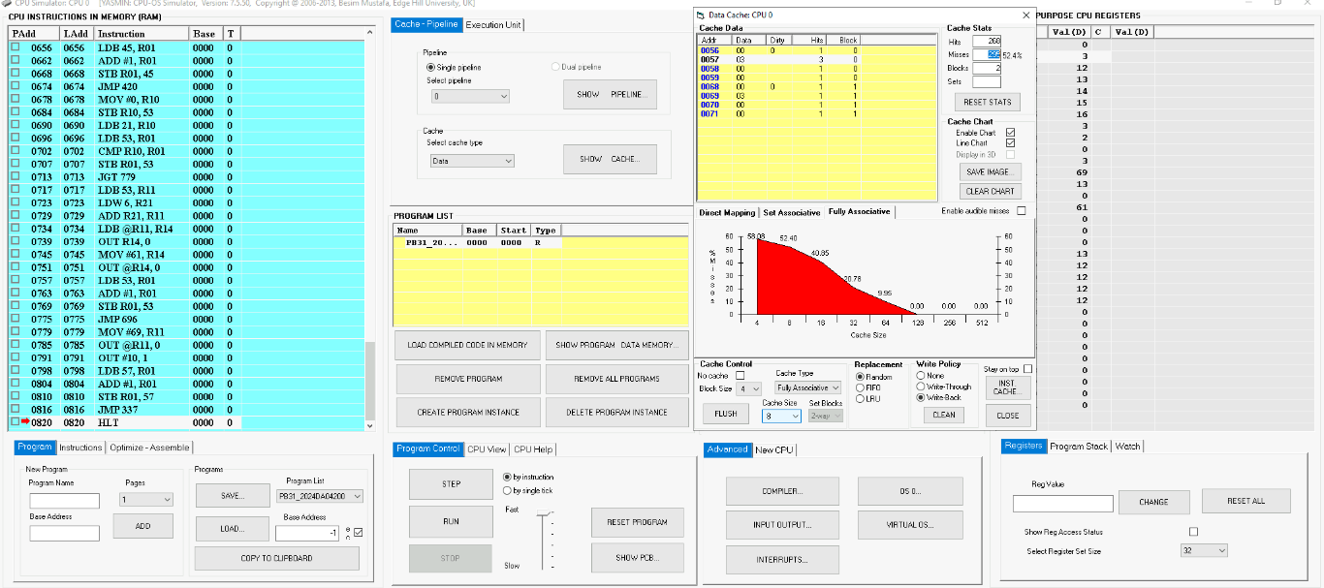

1. BLOCK SIZE = 4, CACHE SIZE = 16

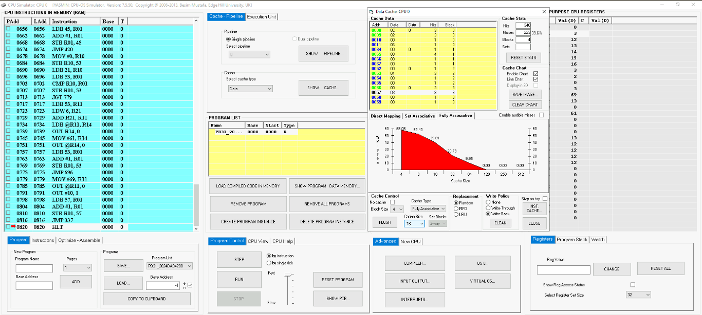

1. BLOCK SIZE = 4, CACHE SIZE = 32

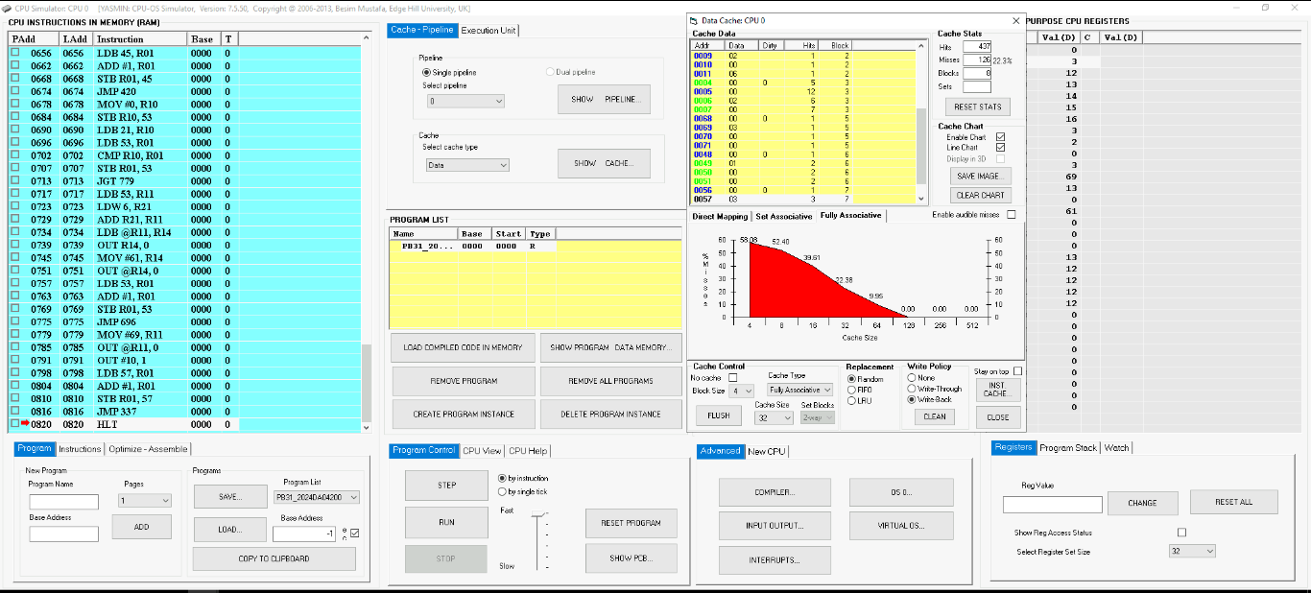

1. BLOCK SIZE = 4, CACHE SIZE = 64

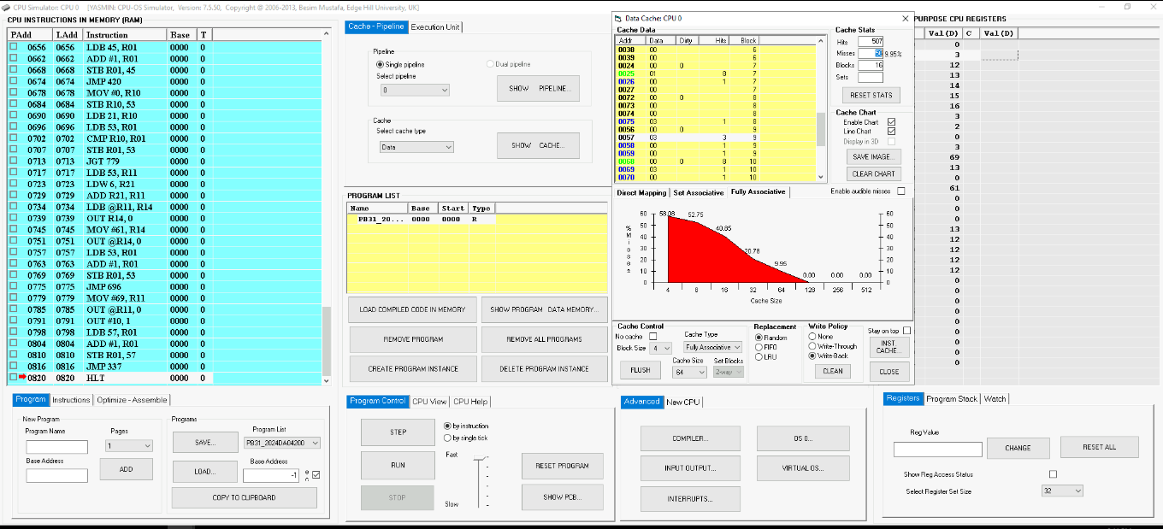

**REPLACEMENT ALGORITHM:** FIFO

1. BLOCK SIZE = 4, CACHE SIZE = 4

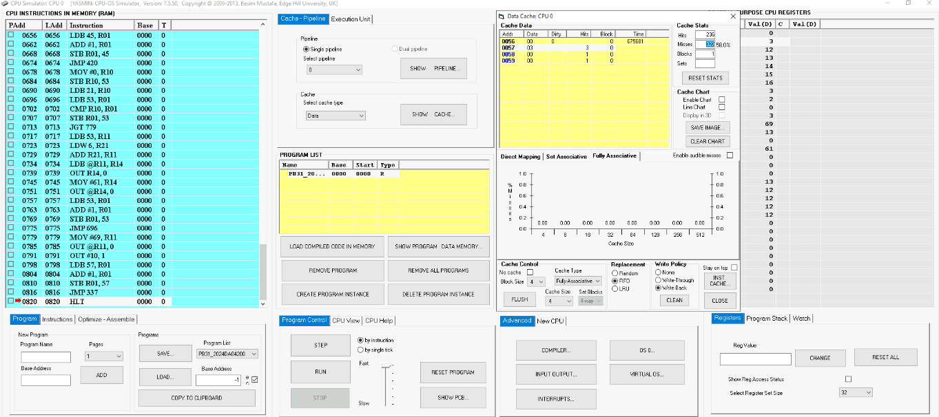

1. BLOCK SIZE = 4, CACHE SIZE = 8

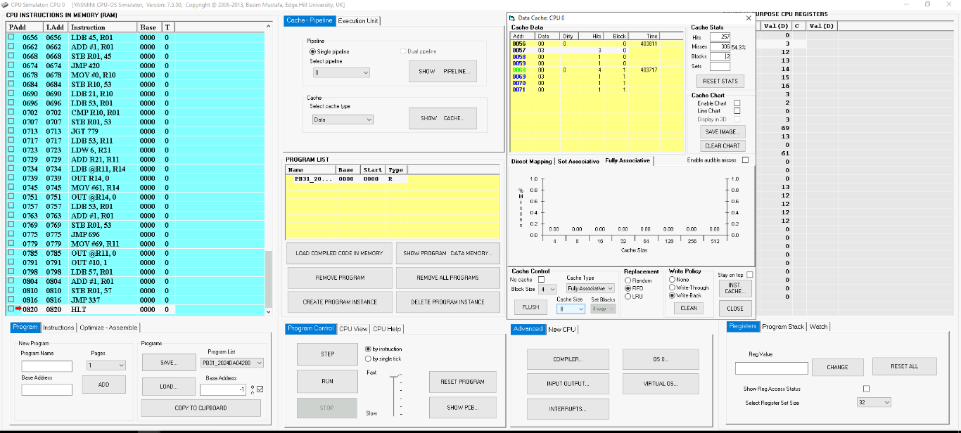

1. BLOCK SIZE = 4, CACHE SIZE = 16

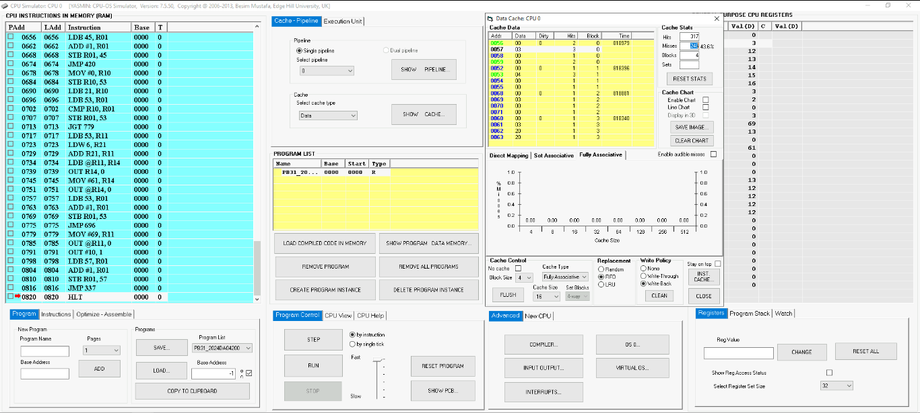

1. BLOCK SIZE = 4, CACHE SIZE = 32

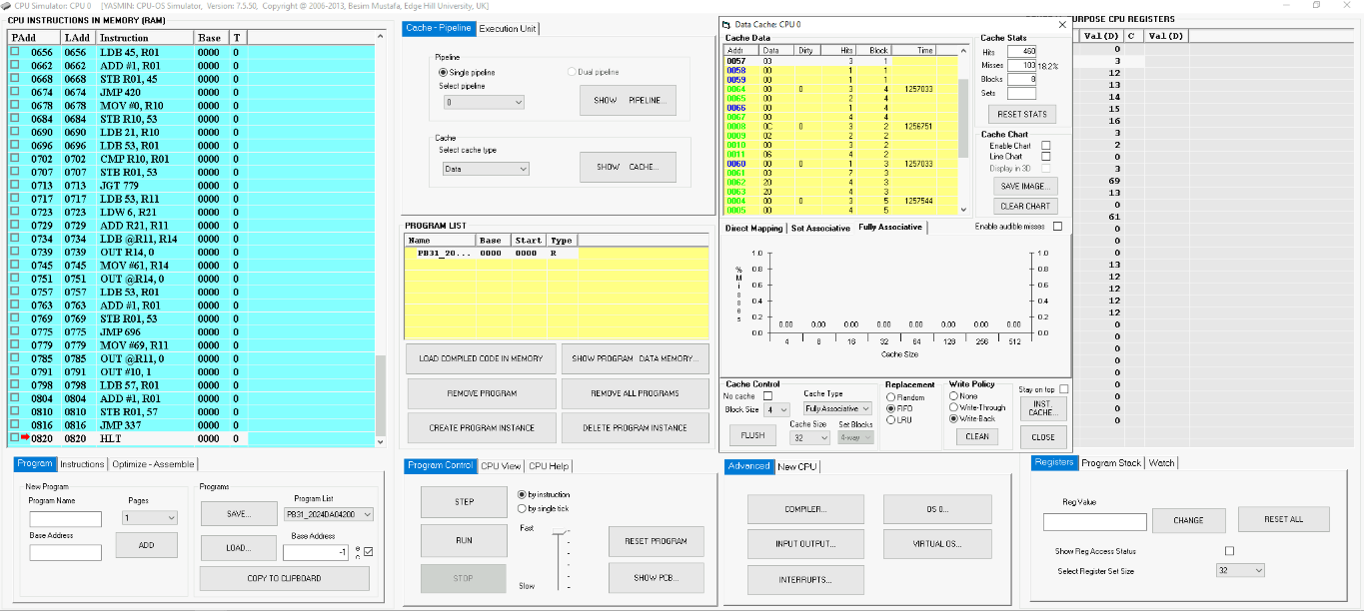

1. BLOCK SIZE = 4, CACHE SIZE = 64

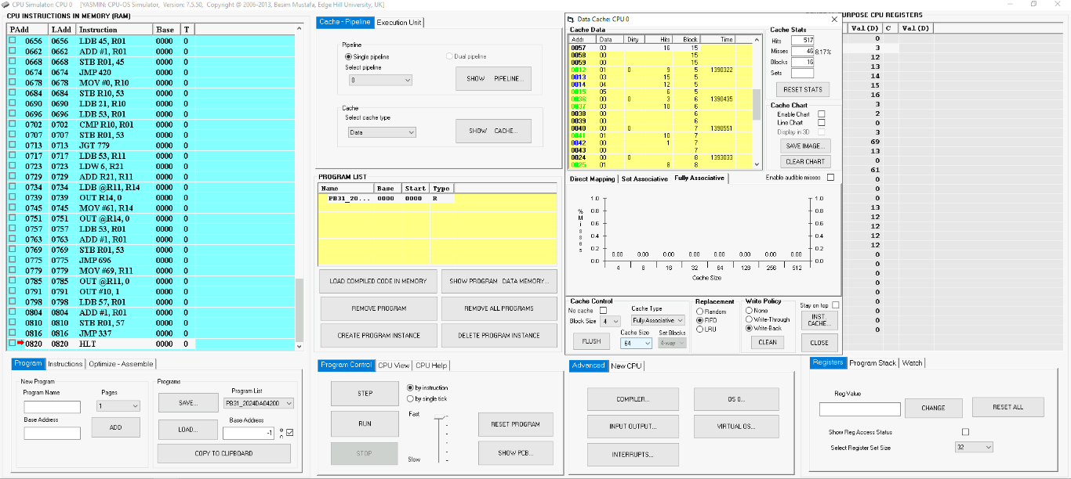

**REPLACEMENT ALGORITHM:** LRU

1. BLOCK SIZE = 4, CACHE SIZE = 4

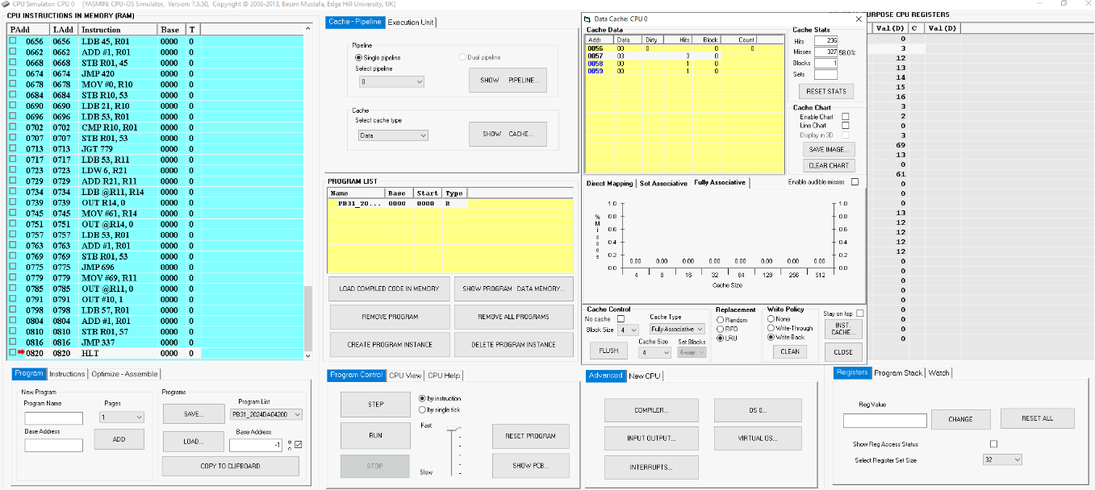

1. BLOCK SIZE = 4, CACHE SIZE = 8

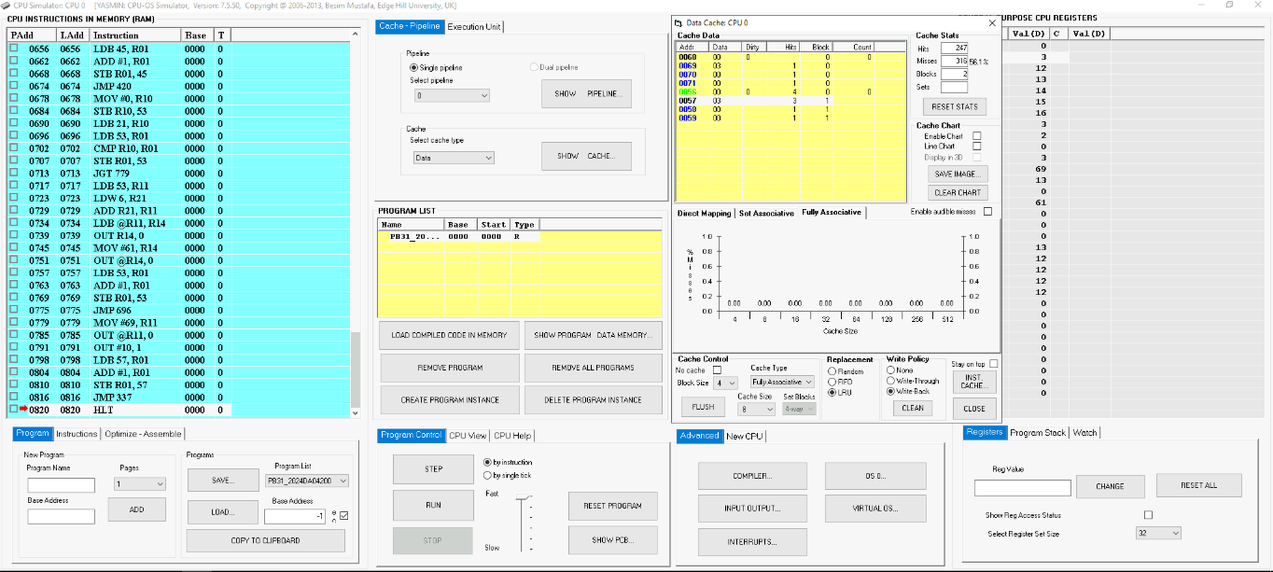

1. BLOCK SIZE = 4, CACHE SIZE = 16

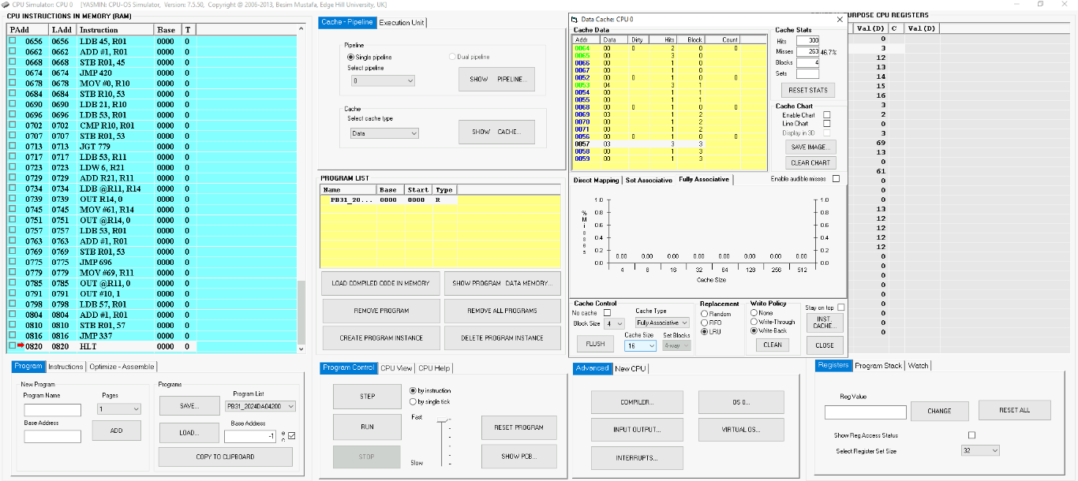

1. BLOCK SIZE = 4, CACHE SIZE = 32

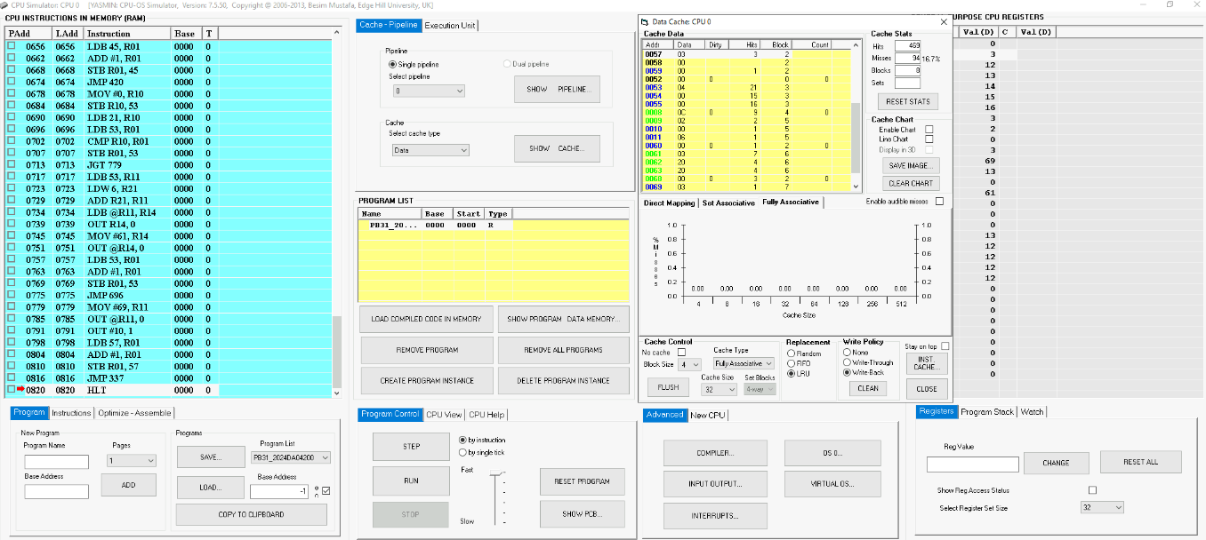

1. BLOCK SIZE = 4, CACHE SIZE = 64

